ASSIGNMENT NO 6

Nirbhay Ahir

[Nirbhay.ahir36@gmail.com](mailto:Nirbhay.ahir36@gmail.com)

1. What are escape characters, and how do you use them?

Ans: To insert characters that would be difficult to use in a code , we use escape characters.

An escape character is a backlash “ \ ” followed by the character we wish to insert.

Eg . \n , \t , \b , \r

2. What do the escape characters n and t stand for?

Ans: \n stands for new line and \t is the tab.

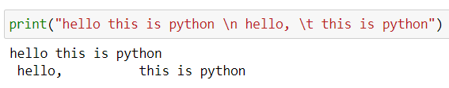

3. What is the way to include backslash characters in a string?

Ans: The \ escape character will represent the backslash character in a string.

4. The string "Howl's Moving Castle" is a correct value. Why isn't the single quote character in the word Howl's not escaped a problem?

Ans: The string "Howl's Moving Castle" is a correct value as it escaped the problem because it is wrapped inside double quotes “ ” .

If it was wrapped inside a single ‘ ‘ then we have to use \ operator to escape the single quote in Howl’s word.

5. How do you write a string of newlines if you don't want to use the n character?

Ans: Multiline string allow you to use newlines in string without the \n escape character..

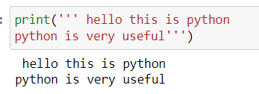

6. What are the values of the given expressions?

'Hello, world!'[1] 'Hello, world!'[0:5] 'Hello, world!'[:5] 'Hello, world!'[3:]

Ans:

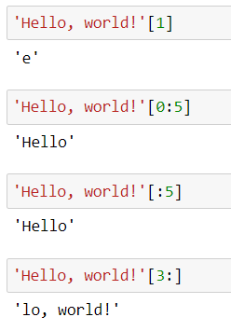

7. What are the values of the following expressions?

'Hello'.upper() 'Hello'.upper().isupper() 'Hello'.upper().lower()

Ans:

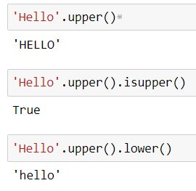

8. What are the values of the following expressions?

'Remember, remember, the fifth of July.'.split()

'-'.join('There can only one.'.split())

Ans:

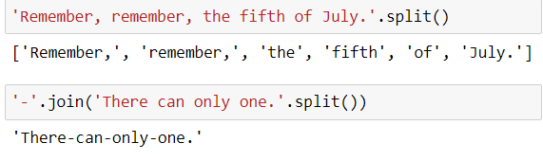

9. What are the methods for right-justifying, left-justifying, and centering a string?

Ans: The three methods are rjust() , ljust() and center().

We have to pass arguments (width , fillchar = ‘ ‘)

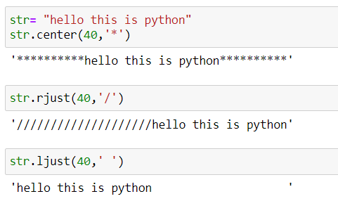

10. What is the best way to remove whitespace characters from the start or end?

Ans: The lstrip() and rstrip() methods remove whitesapce characters from the left and right ends of a string respectively.

